**16. Technical Documentation**

By using the data in the technical documentation a system analyst can understand how the system works and can perform software updates and amendments. It contains an overall system flowchart, top-down design of the system, flowcharts of data manipulation, search, transaction processing. It also contains the file structure of different tables and relationship between the tables. It also contains the hardware and software requirement to use/update the current software.

Features of the New Software

* It provides a user interface to manipulate the data in the database such as adding, editing, and deleting).
* It provides a query interface to perform data search and report relating to the selected criteria, by inserting key words related to the criteria and requested data.
* It allows navigation to and from the different forms of the software by using a central Main Menu.
* It provides a security system so that only authorized people can login to the system.
* It provides validation for different sorts of data to prevent any errors.

I performed testing of the system using a test strategy and also showed the test results. To see them, check in testing phase (Pg: , Fig)

Overall System Flowchart (Fig 5.01)

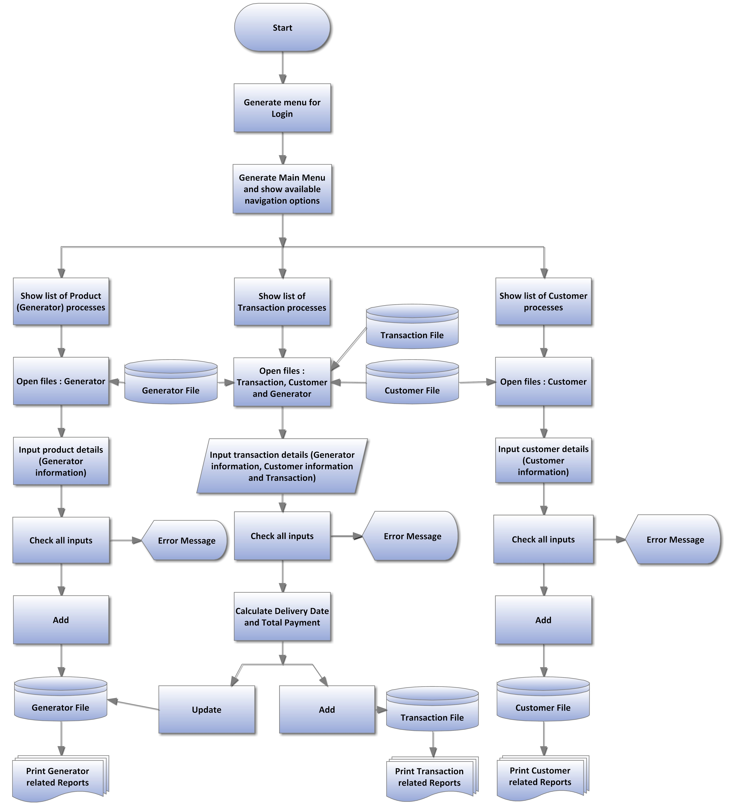

Top-down design of the new system (Fig 5.02):

To show a helicopter view of the new system and its processes

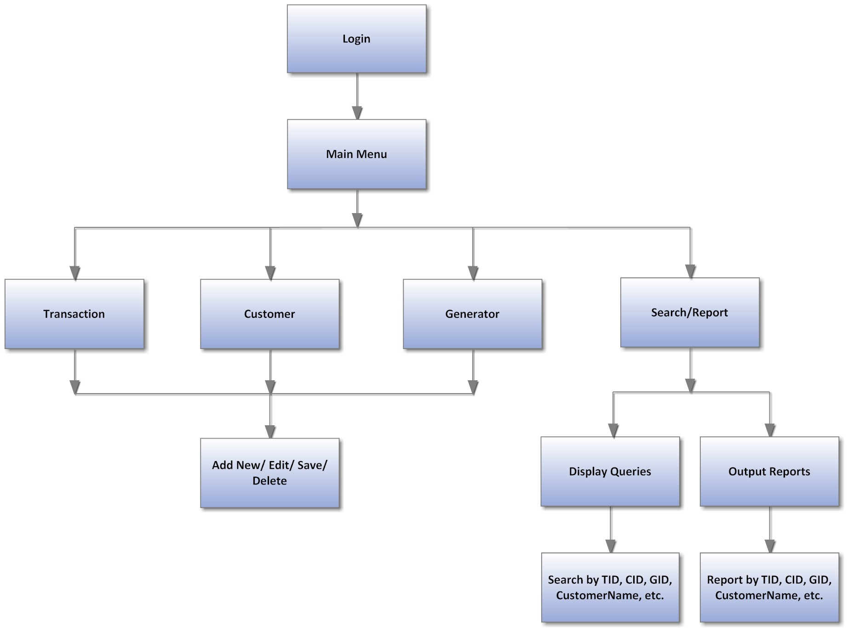

Other flowcharts for different processes:

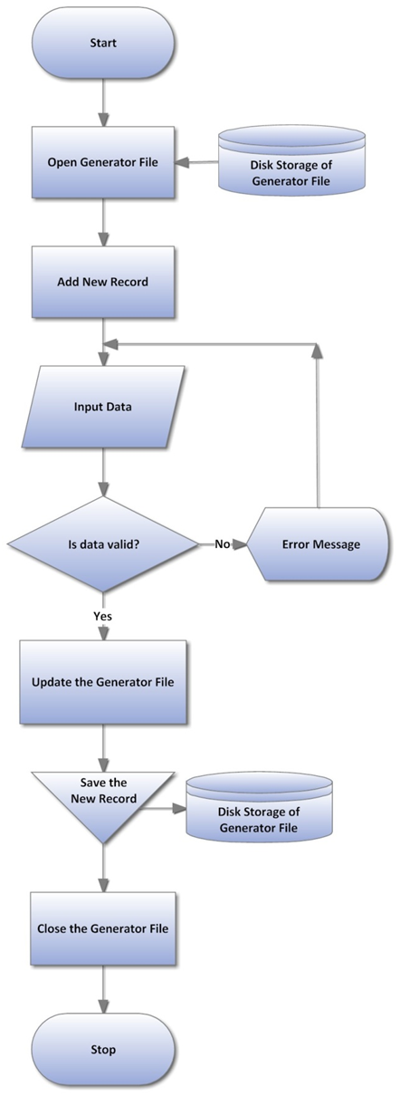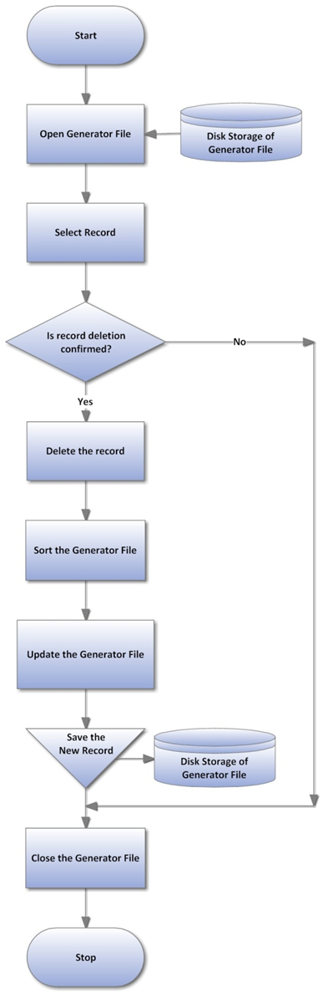

Fig 5.03: Adding a New Record in Generator Table

Fig 5.04: Deleting a Record in Generator Table

Fig 5.05: Editing a Record in Generator Table

Fig 5.06: Searching a Record in Generator Table

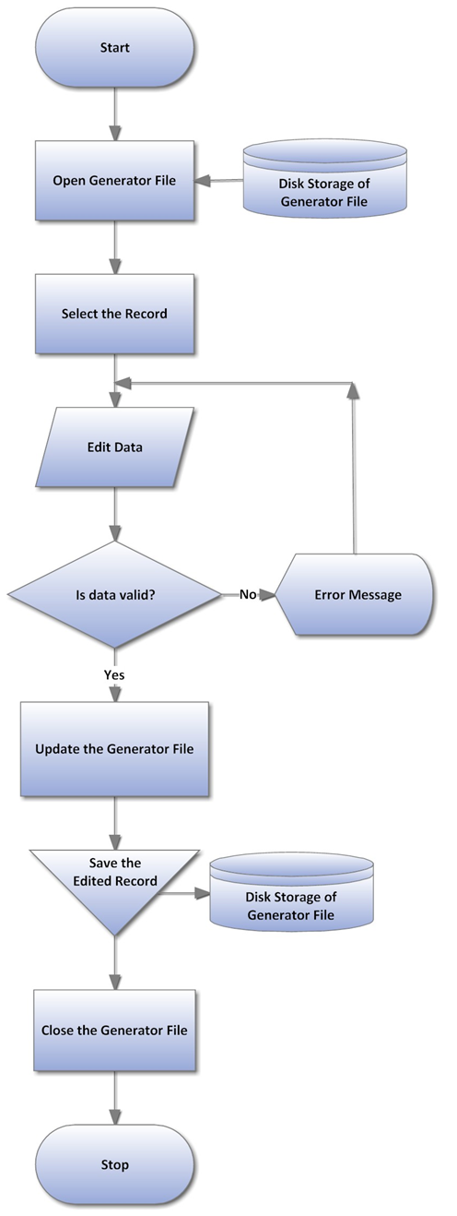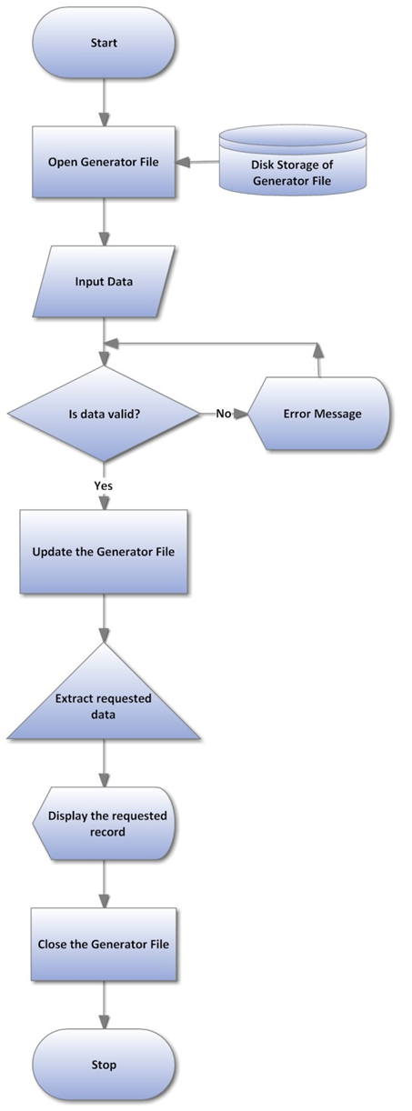

Fig 5.07: Saving a Record in the Generator Table

Fig 5.08: Transaction Processing

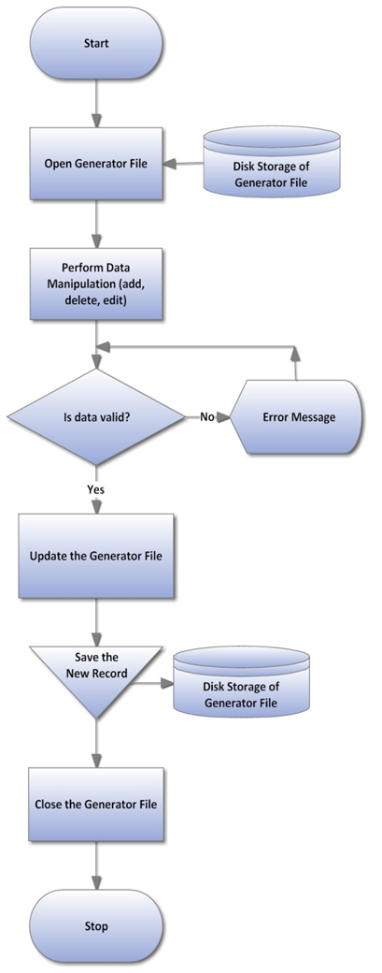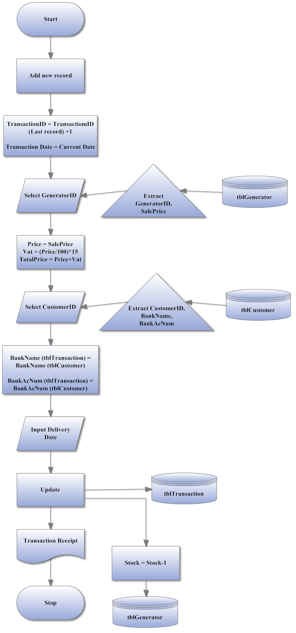

Input Layout of the Transaction Form (Fig 5.09)

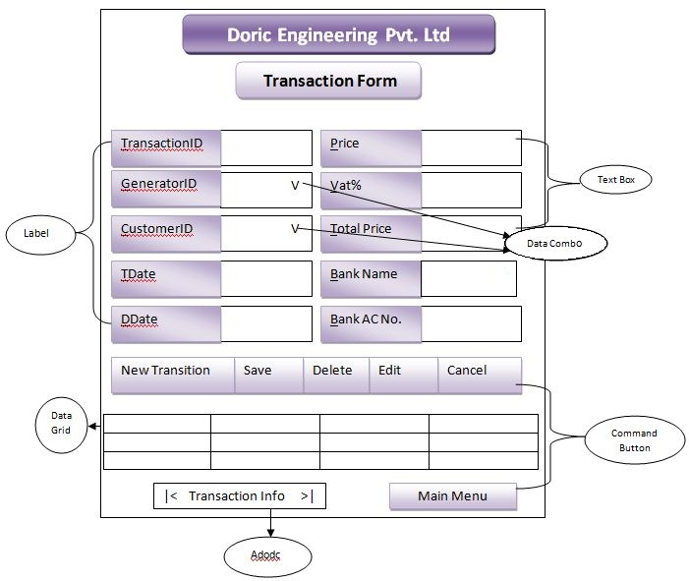

The input layout of the Customer Form and the Generator Form are similar to the input layout of the Transaction Form (Fig 2.10).

Output Layout of the Transaction Report (Fig 5.10)

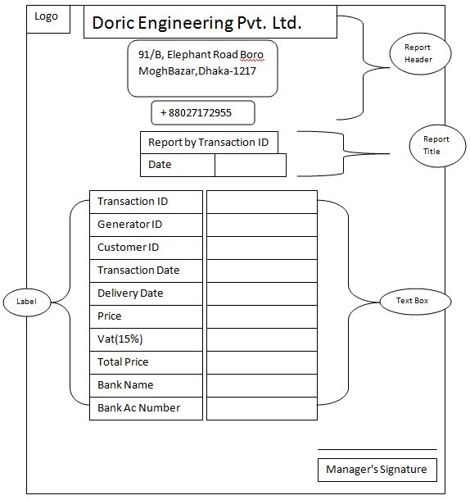

The design output layout of the Customer Report, Generator Report, etc is similar to that of the Transaction Report (Fig 2.11)

Database Design:

To illustrate the database of the new system, showing tables and how data is stored with data type, field size and data format with examples. It also shows the relationship among the tables.

The designed tables are in the following page.

Transaction Table

|  |  |  |  |  |
| --- | --- | --- | --- | --- |
| Field Name | Data Type | Field Size | Format | Example |
| TID (Primary Key) | Text | 6 | T##### | T10001 |
| GID | Text | 4 | G### | G101 |
| CID | Text | 5 | C#### | C1001 |
| TDate | Date | 10 | DD/MM/YYYY | 17/03/2007 |
| DDate | Date | 10 | DD/MM/YYYY | 17/04/2007 |
| Price | Currency | Long Integer | £……….. | £50,000.00 |
| Vat | Currency | Long Integer | £……….. | £7,500.00 |
| TotalPrice | Currency | Long Integer | £……….. | £57,500.00 |
| BankName | Text | 15 | N/A | EXIM |
| BankAcNumber | Number | Long Integer | N/A | 115877674 |

Customer Table

|  |  |  |  |  |
| --- | --- | --- | --- | --- |
| Field Name | Data Type | Field Size | Format | Example |
| CID (Primary Key) | Text | 5 | C#### | C1001 |
| CustomerName | Text | 25 | N/A | Afroz Al Mamun |
| Gender | Text | 6 | Male/Female | Male |
| PhoneNumber | Text | 11 | N/A | 01823357448 |
| EmailID | Text | 30 | ….@..... | afroz_27gmail.com |
| Designation | Text | 15 | N/A | Director |
| AssetName | Text | 20 | N/A | Icon College |
| PropertyType | Text | 10 | N/A | Company |
| Address | Text | 40 | N/A | D-Block Lalmatia, Dhaka |
| BankName | Text | 15 | N/A | EXIM |
| BankAcNum | Number | Long Integer | N/A | 115877674 |

Generator Table

|  |  |  |  |  |
| --- | --- | --- | --- | --- |
| Field Name | Data Type | Field Size | Format | Example |
| GID (Primary Key) | Text | 4 | G### | G101 |
| GType | Text | 10 | N/A | 24GFS |
| Model | Text | 10 | N/A | K4100D1 |
| ManufacturerCo | Text | 15 | N/A | Mindong |
| ManufacturingCountry | Text | 15 | N/A | Japan |
| Power_kW | Number | Long Integer | N/A | 24 |
| Voltage_V | Number | Long Integer | N/A | 230 |
| Current_A | Number | Long Integer | N/A | 1500 |
| VoltageModulationRate | Text | 10 | N/A | Exceed 95 |
| PotectionClass | Text | 10 | N/A | IP22 |
| Stock | Number | Long Integer | N/A | 15 |
| Price | Currency | Long Integer | £……….. | £45,000.00 |
| SalePrice | Currency | Long Integer | £……….. | £55,000.00 |

List of Variables

|  |  |
| --- | --- |
| Variable | Purpose/Position |
| xTID | Transaction Form, used in auto ID generation for the Transaction ID |
| xCID | Customer Form, used in auto ID generation for the Customer ID |
| xGID | Generator Form, used in auto ID generation for the Generator ID |
| d | Used to hold the string command for the delete function, in Transaction Form, Customer Form and Generator Form. |
| s | Used, in the Transaction Form, to hold the Numeric data of the “Stock” field in the Generator Table, subtract “1” from the stock and to update the “Stock” field. |
| g | Used to hold the string command for the Generator Type function, in Generator Form. |
| stockconf | Contains Boolean data, Used in Transaction Form for stock update. |

List of Formulas

|  |  |
| --- | --- |
| Field | Formula |
| Vat | txtVat = (Val(txtPrice) / 100) * 15 |
| Total Price | txtTPrice = Val(txtPrice) + Val(txtVat) |
| Delivery Date | txtDDate.Text = DateAdd("d", 15, txtTDate) |

The entity relationships in between the tables are as follows (Fig 5.11):

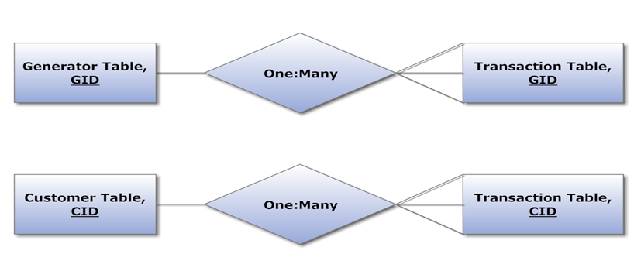

**Hardware requirement**

|  |  |  |
| --- | --- | --- |
| DEVICE | CONFIGURATION | Justification |
| Processor | Intel Core i3 (2.3 GHz) | For faster data processing |
| RAM | 2 GB | For storing more online application data temporarily |
| Hard disk | 500 GB | For storing more data on the database |
| DVD-ROM Drive | ASUS 52-X | For inputting data from optical disks |
| Input devices | Keyboard and Mouse | For manipulating/inputting transaction, customer, etc. details onto the database |
| Printer | Canon ip2772 inkjet | For printing transacting, generator, etc. reports |
| Monitor | 17” color monitor | For viewing the running system |

**Software requirements**

There are many commercial software packages available to solve the drawbacks of the store. For example database software can be used to keep all the records of the store that will perform as the back-end and will also be used to store and access data. The front-end will be designed using a programming language to create user-friendly interfaces. Both the database and the programming language will be used to establish the system, since they can’t be used alone and would easily carry out all the tasks required.

The options for the database software are:

• Microsoft Access

• Microsoft Excel

• Oracle

The options for the programming languages are:

• Visual Basic

• Quick Basic

Database Software:

|  |  |  |
| --- | --- | --- |
| Software | Advantages | Disadvantages |
| MS Access | 1. Easy to create a database.  2. Tables, forms, queries and report generating are easier by using wizard or design mode.  3. Easy to establish relationship between tables in a database. | 1. Can’t handle huge amount of data.  2. When access database file is used, it increases unnecessary size.  3. To solve a specific task, it needs  Visual Basic programming editor or script. |
| MS Excel | 1. Excellent program to create spreadsheet for various modelling and simulation.  2. It has numerous built in functions to solve the mathematical and logical problems.  3. It has different types of charts and graphs. | 1. User defined functions can’t be solved since all the functions are unalterable.  2. Does not support DBMS.  3. Does not create the attractive and user friendly interfaces to run the developed application program. |
| Oracle | 1. It handles huge amount of data.  2. Complex search and report generating can be done easily.  3. It has a strong and maximum data security facility to protect the data. | 1. It requires high skilled programming knowledge to develop the program.  2. It is expensive to afford.  3. It is difficult to program |

|  |  |  |
| --- | --- | --- |
| Software | Advantages | Disadvantages |
| Visual Basic | 1. It is very good application developer that comes with good number of useful tools and components.  2. It is easy and convenient to write program and debug, with it is instructions that is closer to English.  3. It has an attractive and a graphical user interface. | 1. Multiple projects cannot be opened or run in the same window.  2. The developer should have clear programming knowledge.  3. It needs high requirements as MS windows. |
| Quick Basic | 1. User defined functions can be solved.  2. Its syntax (instructions) is close to  English statement, so it is easy to understand.  3. It includes interpreter that converts a  written program into a compiled self | 1. It does not have the good and attractive interfaces.  2. Too many codes (instructions) have to be written to solve the problem. |

**Ideal software that can be used**

ORACLE 8i with Developer 2000 is very powerful to handle large amount of data which is very expedient. But it requires very high skilled and skilled programmer and also it is very expensive. Therefore I have chosen Microsoft Excel and Access.

**Best software to be used to solve the problem**

The database software that will be used would be Microsoft Access 2000 or higher. This will be used as data holder and the programming language would be Microsoft Visual Basic 6.0 (VB98) that will perform as the manipulator of data. It is wise to use both of these; since Access supports all the modules and Structured Query Language (SQL) required for developing the system and also it is less costly. Visual Basic will be used to create the interfaces, since it supports SQL for input and output of data to and from the database, as it will be connected to the database via Microsoft Jet Engine 4.0 using ActiveX Data Object (ADO) control.

**Justifications for writing a problem**

The tasks like validation checking, searching records and report generating would become handy only by a written program though programming language is a bit difficult to learn and utilize. So I used Visual Basic which is comparatively easier to write the program which has facilities that I would need to produce the software, as follows:

1. Its Graphical User Interface has a professional look but yet it is user-friendly
2. When the user writes an object’s name while programming, the programming editor provides the properties and methods automatically
3. Writing the program is done conveniently as the required tools and components are provided.
4. Visual Basic programming language allows modular programming, which increases the usability of programs as a common function.
5. Different types of colour codes are used to show the different modes of the program, that helps the programmer to know whether he is going in right way or not.

Moreover, any kind of calculation and checking can be performed. Additionally, the program would give proper security to the records by the use of passwords.

**17. User Guide**

Installing the software

1. Insert the disk which contains the software.
2. Install the software (Make sure to install in C:\Program Files).

If the software is not installed in drive C, then the following error message will be shown (Fig 5.12).

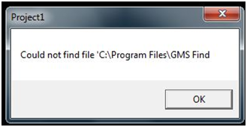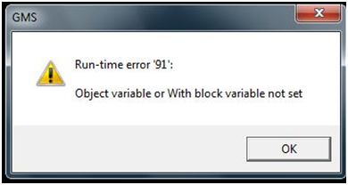

5.12

Running the software

1. After the software is setup, then the software can be used my using the following shortcuts, either by starting if from the start menu- or by using the desktop shortcut “GMS.exe”.
2. See the following procedures of the user guide to know how to use the different functions of the software.

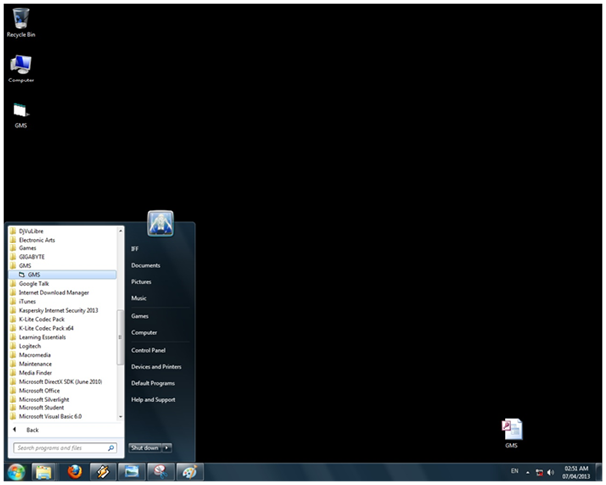

5.13

Security Form

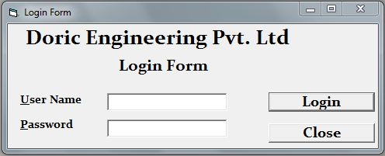

Fig 5.14

This is the Login Form when opened

1

2

1

3

1

|  |  |
| --- | --- |
| Label | The function it represents |
| 1 | To navigate login to the system |
| 2 | To close of the software |
| 3 | To input the user name and password |

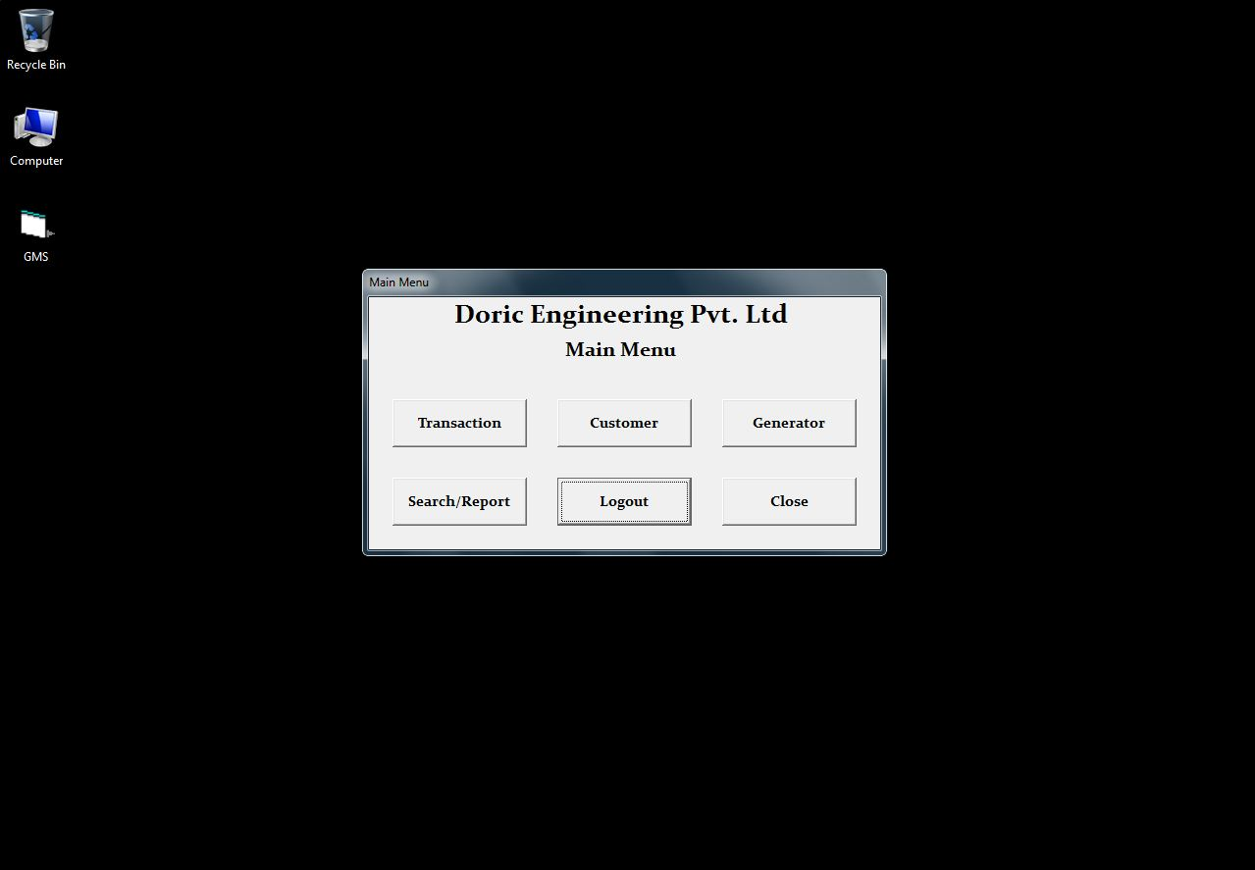

1

3

2

1

5

6

4

Fig 5.15

|  |  |
| --- | --- |
| Label | The function it represents |
| 1 | To navigate to the Transaction From |
| 2 | To navigate to the Customer From |
| 3 | To navigate to the Generator From |
| 4 | To navigate to the Search/Reprort From |
| 5 | To Log out of the software |
| 6 | To Close the software |

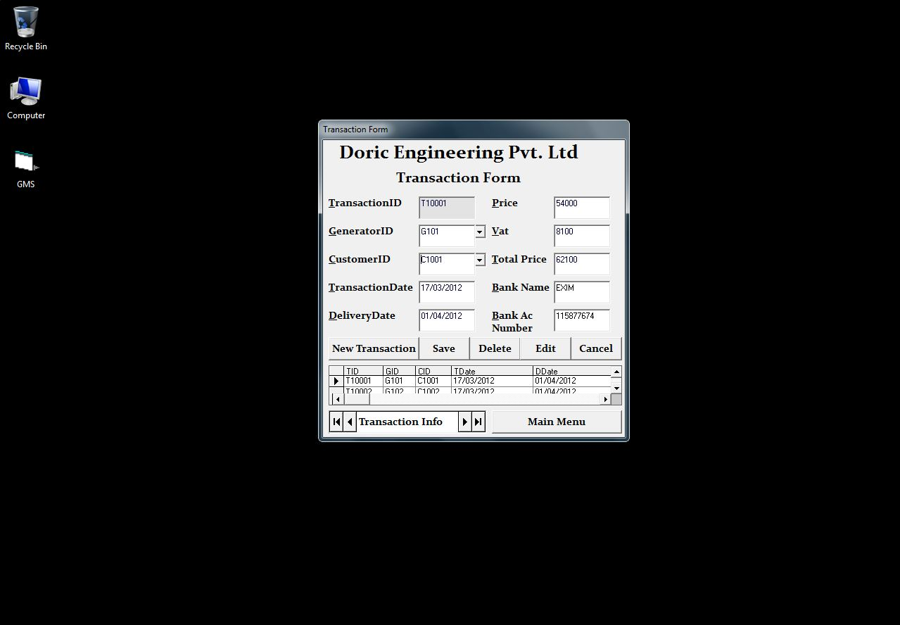

2

4

3

1

5

6

7

1

5.16

Transaction Form

|  |  |
| --- | --- |
| Label | The function it represents |
| 1 | To input data using a data combo list from the database |
| 2 | To add a new record |
| 3 | To save the record |
| 4 | To delete the record |
| 5 | To edit the record |
| 6 | To cancel the action |
| 7 | To show the database table |

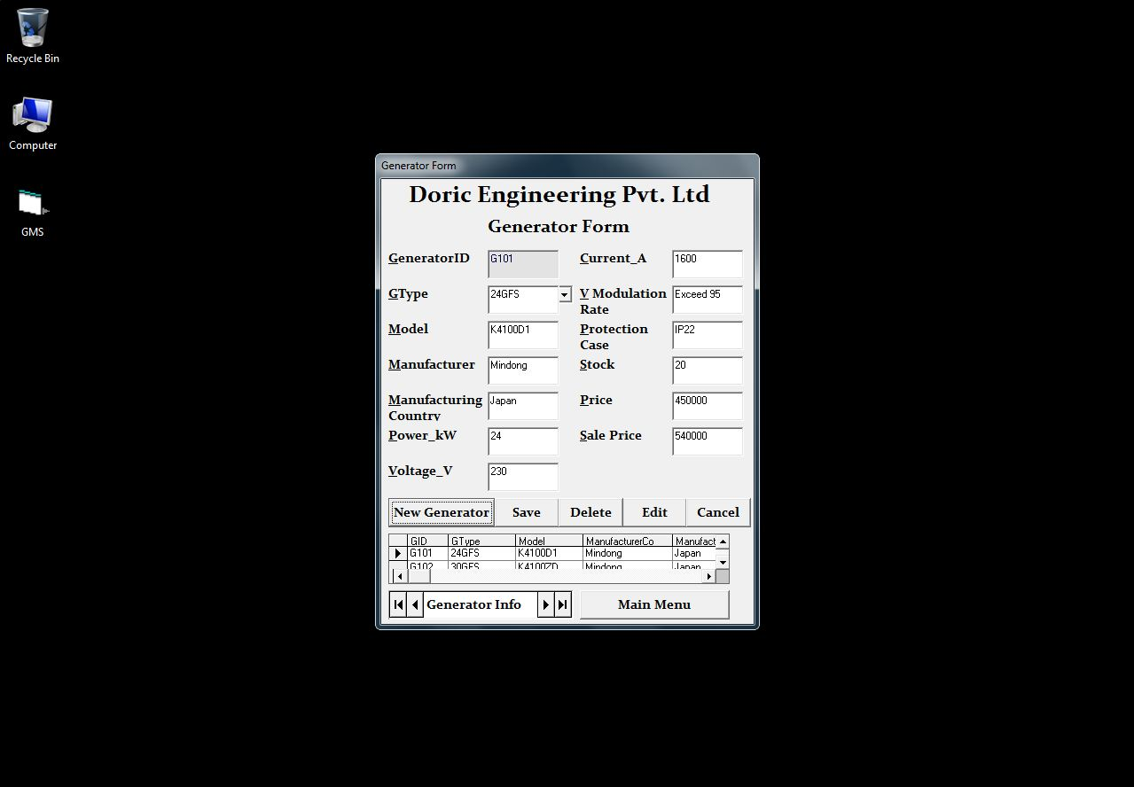

2

4

3

1

6

7

1

5

5.17

Generator Form

|  |  |
| --- | --- |
| Label | The function it represents |
| 1 | To input data using a data combo list from the database |
| 2 | To add a new record |
| 3 | To save the record |
| 4 | To delete the record |
| 5 | To edit the record |
| 6 | To cancel the action |
| 7 | To show the database table |

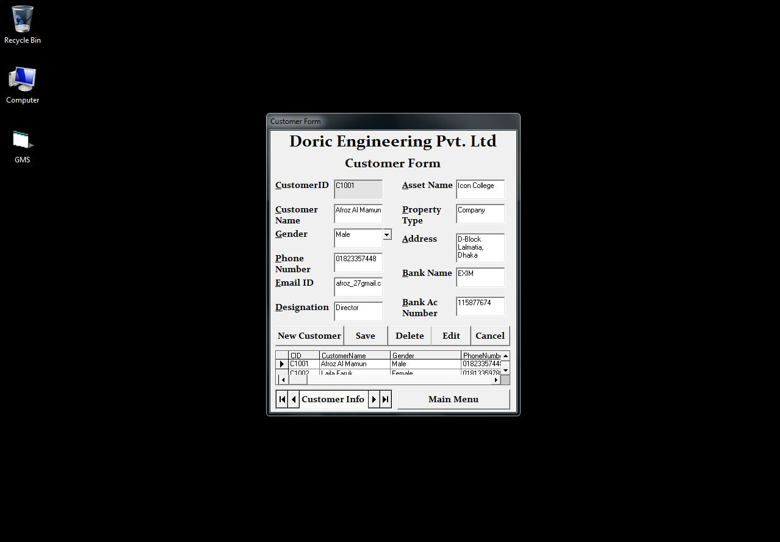

2

4

3

1

6

7

5

1

5.18

Customer Form

|  |  |
| --- | --- |
| Label | The function it represents |
| 1 | To input data using combo list |
| 2 | To add a new record |
| 3 | To save the record |
| 4 | To delete the record |
| 5 | To edit the record |
| 6 | To cancel the action |
| 7 | To show the database table |

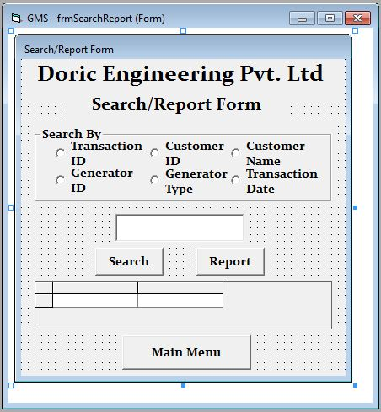

1

3

2

1

5

6

4

7

9

8

10

11

5.19

|  |  |
| --- | --- |
| Label | The function it represents |
| 1 | To select search criteria “Transaction ID”” |
| 2 | To select search criteria “Customer ID” |
| 3 | To select search criteria “Customer Name” |
| 4 | To select search criteria “Generator ID” |
| 5 | To select search criteria “Generator Type” |
| 6 | To select search criteria “Transaction Date” |
| 7 | To input the search keyword |
| 8 | Outputs the search result |
| 9 | Outputs the report |
| 10 | Navigates to the main menu |
| 11 | Shows the search output |